**Bahria University Karachi Campus**



**Object Oriented Programming Lab**

**CSL 210**

**BSCS (2-B)**

**Cricket Stadium Ticket Booking System**

* **Muhammad Isam (045)**
* **Sofia Haider (090)**
* **Zobia Gul (064)**

**Theory Instructor: Ms.Sameena Javaid**

**Lab Instructor: Ms.Salas Akbar**

**Introduction:**

This plan calls for creating a cricket stadium ticketing system. The system will offer the cricket stadium an automated, effective, and secure ticket booking solution. Users will be able to reserve tickets for matches through the system, which will also offer details on ticket availability and costs. Users will be able to promptly obtain their tickets and make secure payments through the system. The system will include a user-friendly interface that will make it simple for users to navigate. To ensure data security, the system will be designed using the most recent technology and secure protocols.

**Overview:**

This project is about a computerized system that makes it easier to buy tickets for cricket games at stadiums called the "Cricket Stadium Ticket Booking System". Customers can use the system to buy tickets online. Additionally, customers can browse seating charts and look for ticket availability. The system aids stadium administration in managing seating plans and keeping track of ticket sales. The technology also enables them to specify their preferred method of payment and the enclosure's row in which they desire a seat.

**UML:**

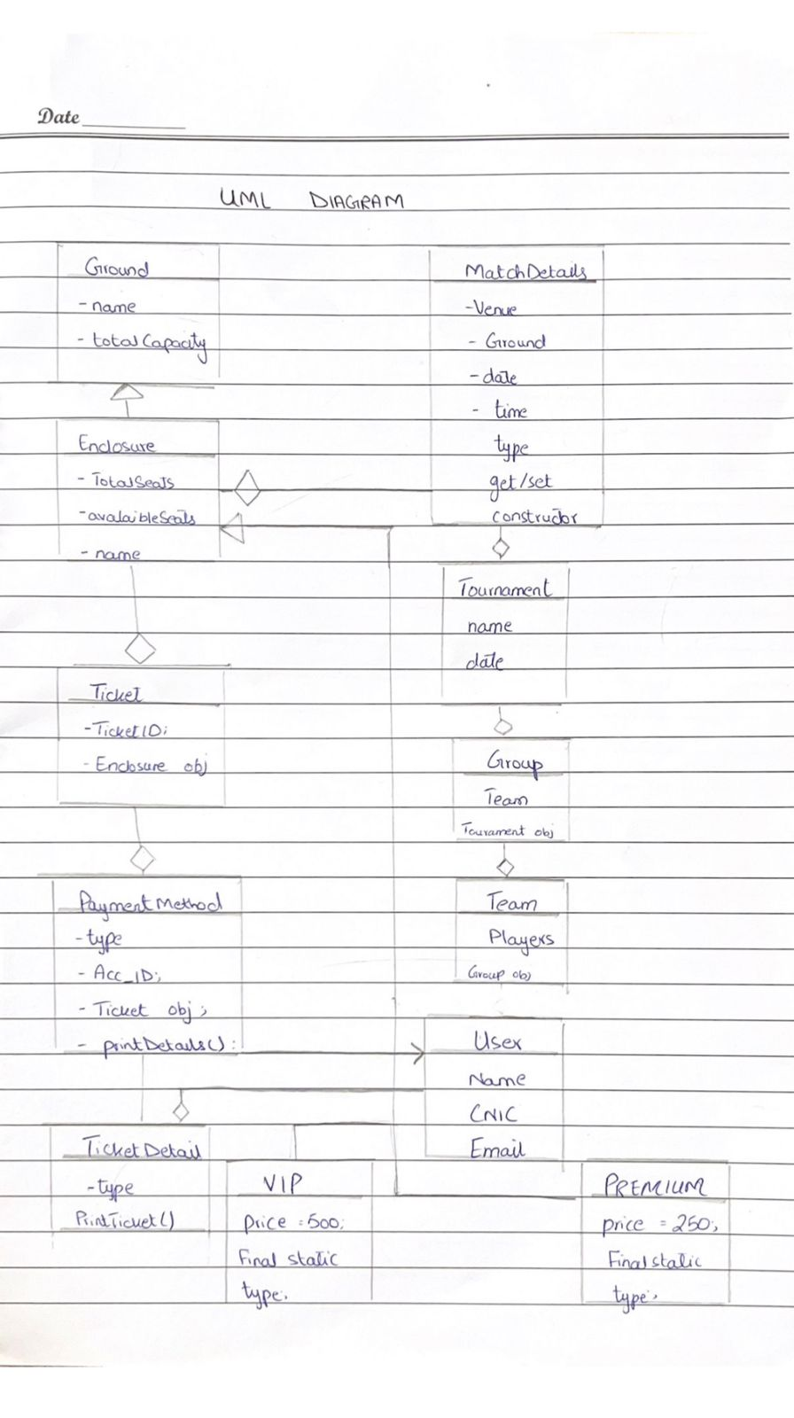

**Work Distribution per member:**

* MUHAMMAD ISAM:

He will be dealing with the programming, GUI of the project.

* ZOBIA GUL:

She will be managing the documentation and the database alongside the programming.

* SOFIA HAIDER:

She will be dealing with the programming and the documentation.